Eurobodalla Shire Council
Wednesday 1 July 2020

Look after your tackle

Local and visiting fishers are being urged to ‘look after their tackle’ in a new nationwide campaign aimed at reducing lost fishing line in waterways.

Fishing line is one of the top-20 items of litter impacting Australian waterways, where it can kill and injure marine life.

An initiative of the Tangaroa Blue Foundation, the ‘look after your tackle’ campaign urges recreational fishers to properly dispose of fishing tackle and to “know their knots” to prevent unexpected losses.

Fishers can even test themselves against knot-tying expert Adam Royle, from the Australian National Sportfishing Association, and try to beat his 9.5-second improved clinch knot.

Eurobodalla Council’s environmental education officer Bernadette Davis said fishing line remained in the aquatic environment long after it had been thrown away.

“Discarded fishing line can severely injure or kill marine mammals and sea birds by entanglement, restricting their mobility and causing starvation, infection, amputation and eventually death,” she said.

“We are asking our local and visiting fisherfolk to get on board with this national campaign and ‘look after your tackle’. Make sure you take any line or packaging with you when you are out at your favourite fishing spot and check that your knots are secure to avoid loss of gear.”

Council has installed fishing tackle debris bins at popular fishing locations throughout Eurobodalla for beachgoers and anglers to use, maintained by fabulous volunteers.

“Next time you are out and see one of our 'tackle bins', take a moment to look around and pick up any discarded fishing tackle you see - you may just be saving a life,” Ms Davis said.

“And if you have a favourite fishing spot with a discarded fishing line problem, we would like to hear about it.
“Contact Bernadette.davis@esc.nsw.gov.au to find out how you can help.”

For more information on the campaign – including the ‘know your knots’ challenge – head to www.tangaroablue.org/amdi-network/reefclean/lookafteryourtackle/

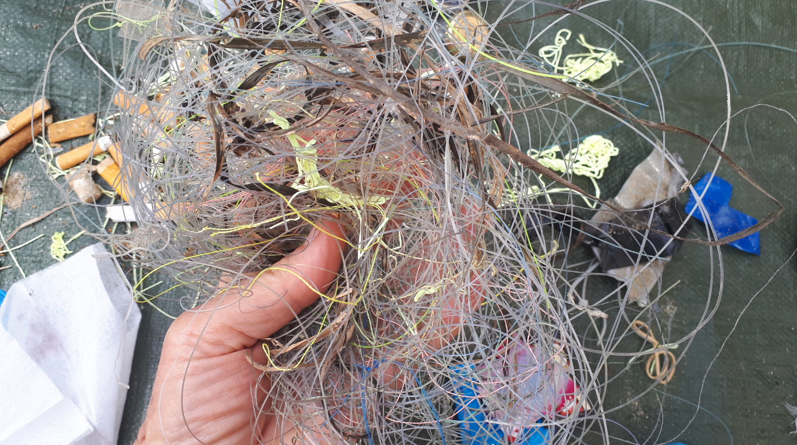
Discarded fishing line found at the Moruya Breakwall.
For all media enquiries, please contact 02 4474 1012 | 0448 005 166 | council.media@esc.nsw.gov.au

